Pricelist User Manual

Introduction
A pricelist helps to set custom prices for products. Discounts, fixed prices, or formula-based pricing can be applied to specific products, categories, or all products and categories
Use pricelists to offer special pricing to certain customers, create bulk discounts, or run time-limited promotions.

Enabling Pricelists
- Go to Sales app → Configuration → Settings.
- In the Pricing section, tick Pricelists checkbox.
- Click Save.
- Access pricelists from Sales app → Products → Pricelists.
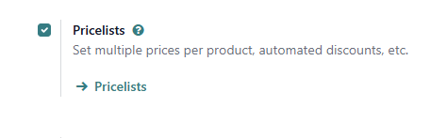

Creating a Pricelist
- Go to Sales app → Products → Pricelists.
- Click New.
- Enter a Pricelist Name (e.g., "VIP Discount", "Wholesale Pricing").
- (Optional) Select Country Groups for region-specific pricing.

Adding Price Rules
Price rules define how prices are calculated for products in this pricelist.
- Under Rules tab, click Add a line
- Configure the rule (see options below).
- Click Save & Close.

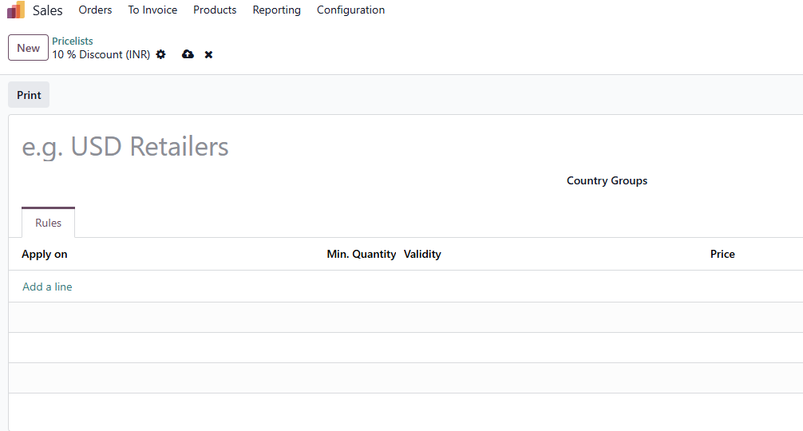

Apply To Options
- All Products – Rule applies to everything
- All Category – Rule applies to all product categories
- Product – Rule applies to a specific product
- Category – Rule applies to a specific product category

Price Types

1. Discount
- Enter percentage discount (e.g., 10 = 10% off)
- Use negative value for markup (e.g., -20 = 20% increase)
2. Formula
- Based price - Select the price used for calculation:
Sales Price – Based on product selling price
Cost Price – Based on product cost
Other Pricelist – Based on another pricelist

- Discount: Enter the percentage to reduce from the base price
- Round off to: Rounds the final price to nearest multiple of the entered value.
- Extra Fee: Add/subtract fixed amount after rounding

3. Fixed Price
- Set a specific price regardless of original price

Additional Options
- Min Qty – Minimum quantity required for rule to apply
- Validity Period – Date range when rule is active

Examples

10% Discount for all products.
- Add a price rule.
- Apply To: All Products.
- Price Type: Discount.
- Discount: 10.

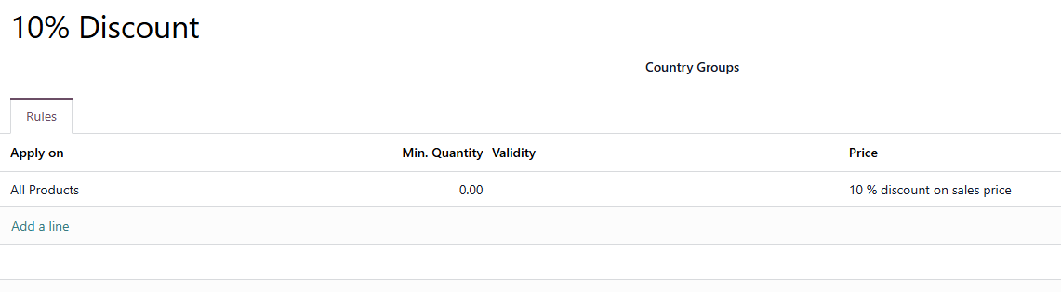

Bulk Discount: Buy 5+, Get 15% Off
- Add a price rule.
- Apply To: Product (select product).
- Price Type: Discount.
- Discount: 15.
- Min Qty: 5.

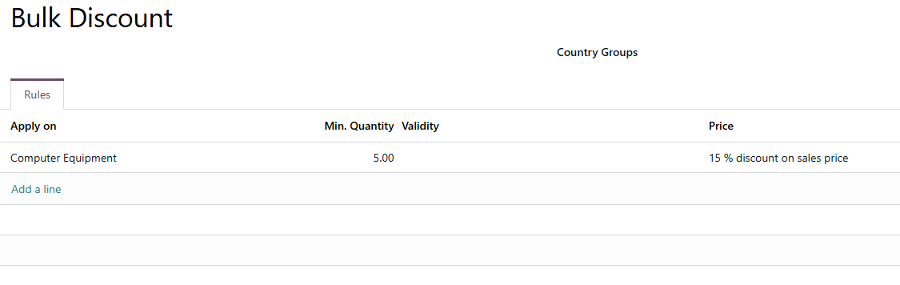

Fixed Price for Specific Product
- Add a price rule.
- Apply To: Product (select product).
- Price Type: Fixed Price.
- Enter the fixed price.

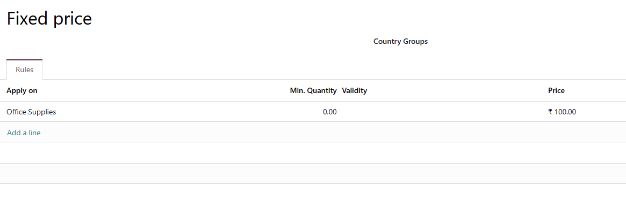

Summer Sale (Limited Time)
- Add a price rule.
- Apply To: Product Category (select category).
- Price Type: Discount.
- Discount: 20.
- Set Validity Period with start and end dates.

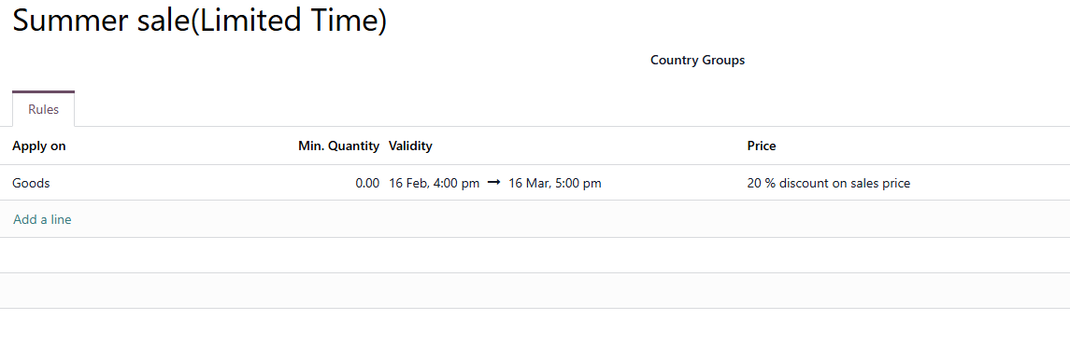

Assigning Pricelist to a Customer
- Go to Sales app → Orders → Customers.
- Open the customer's contact.
- Go to Sales & Purchase tab.
- In Pricelist field, select the pricelist.
- Save.
Now all quotes for this customer will automatically use this pricelist.
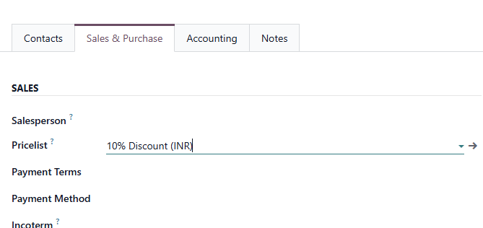

Using Pricelist on a Sales Order
- Create or open a quotation.
- Find the Pricelist field.
- Select the desired pricelist.
- Prices on order lines will update automatically.
Tip: You can always manually override prices on the sales order if needed.
